**Heart Disease Prediction**

**``````````````````````````````````````````````````````````````````````````````**

**Name**  : Gurucharan Rao

**Reg**  : 11804634

**Section**: KM032

**Roll**  : B51

------------------------------------------------------------------------------

**Introduction**:

We have data which classified if patients have heart disease or not according to features in it. We will try to use this data to create a model which tries to predict if a patient has this disease or not. We will use a logistic regression (classification) algorithm.

**Data contains;**

* age - age in years
* sex - (1 = male; 0 = female)
* cp - chest pain type
* trestbps - resting blood pressure (in mm Hg on admission to the hospital)
* chol - serum cholesterol in mg/dl
* fbs - (fasting blood sugar > 120 mg/dl) (1 = true; 0 = false)
* restecg - resting electrocardiographic results
* thalach - maximum heart rate achieved
* exang - exercise induced angina (1 = yes; 0 = no)
* oldpeak - ST depression induced by exercise relative to rest
* slope - the slope of the peak exercise ST segment
* ca - number of major vessels (0-3) colored by fluoroscopy
* thal - 3 = normal; 6 = fixed defect; 7 = reversible defect
* target - have disease or not (1=yes, 0=no)

**Data Visualization:**

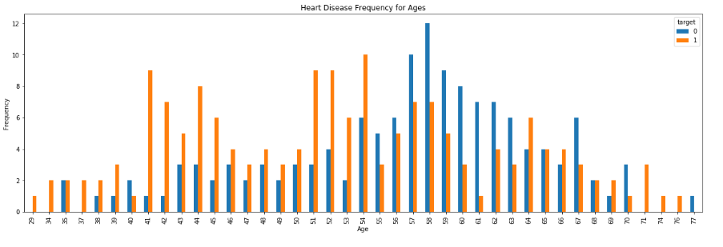

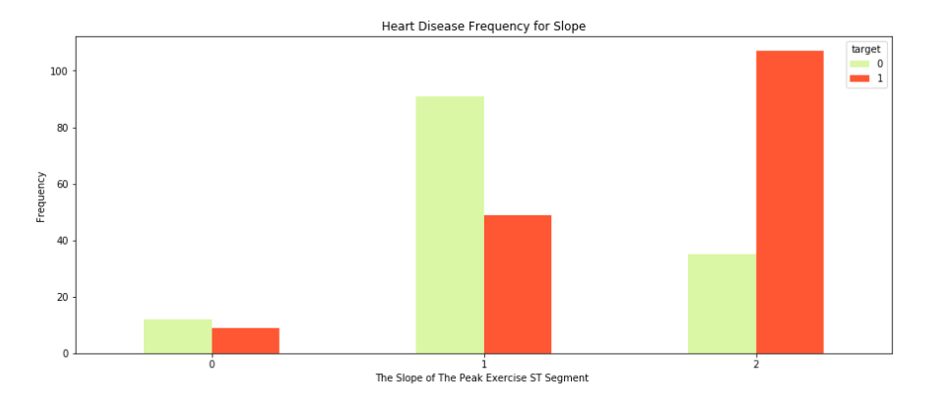

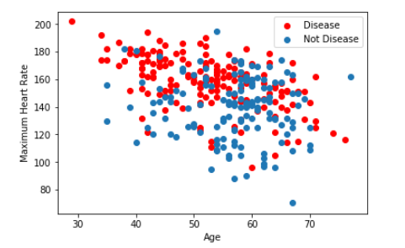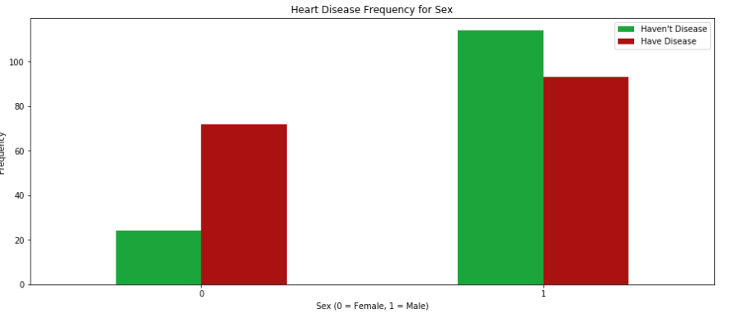

**Creating Model for Logistic Regression:**

sigmoid(z) = 1/(1+ np.exp(-z))

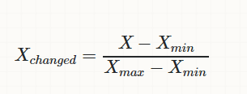

**Sigmoid :**

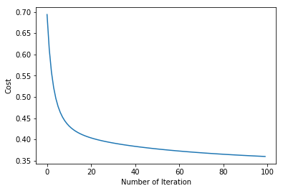

**K-Nearest Neighbour (KNN) Classification:**

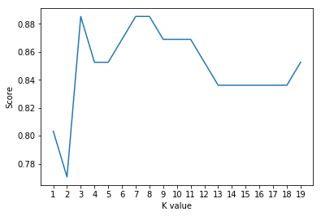

**Confusion Matrix:**

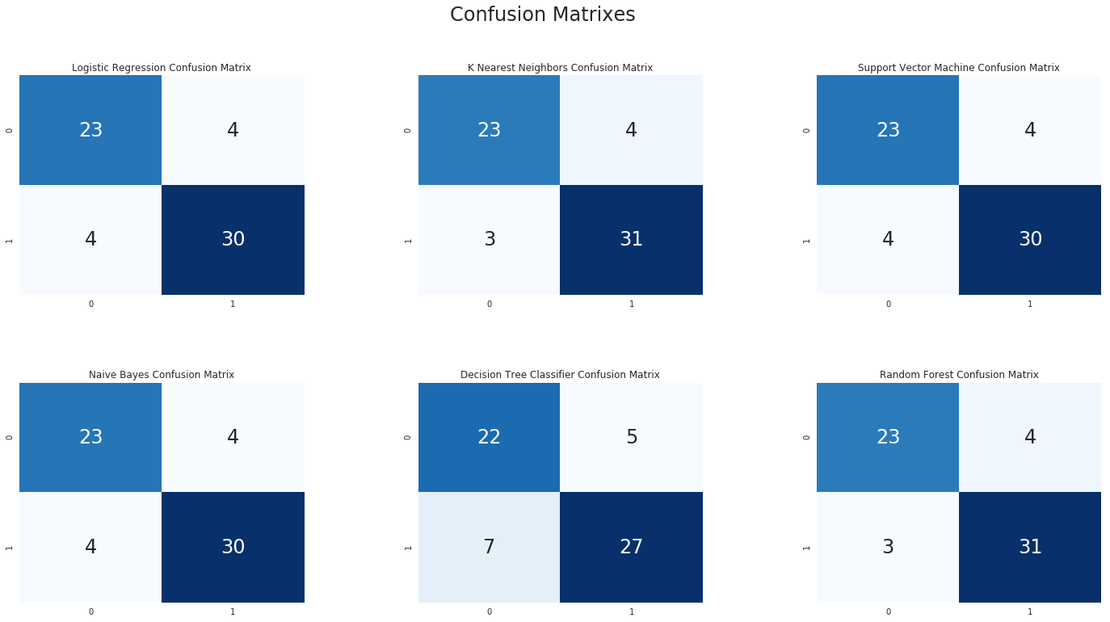

**Models Used:**

**`````````````````**

->logistic regression (classification) algorithm.

->Support Vector Machine (SVM) Algorithm.

->K-Nearest Neighbour (KNN) Classification.

->Decision Tree Algorithm.

-> Random Forest Classification

**THANKYOU**